Year 6 Natural Disasters Topic – KIRFs
Autumn 1
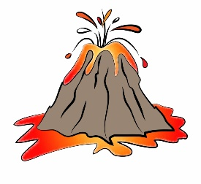
- The four main types of volcano are composite, lava dome, shield and cinder cone.
- The location and main areas of natural disaster activity are at the edges of tectonic plates.
- There are several types of natural disasters.
- The surface of the Earth consists of tectonic plates.
- A famous volcanic eruption was Vesuvius in 79AD (Roman times).
- Tectonic plates can move against each other in different ways.
- There was once a huge continent called Pangea.

