SCIENCE
What is a switch?
Switches are used to control the flow of electricity around a circuit. If a switch is open then electricity can’t complete the loop. If it is closed then electricity can complete the loop.
They are useful because you can turn off things like lights so that you don’t waste the electricity.
A switch can go anywhere in a circuit.

SCIENCE
What is a simple circuit?
A circuit is a complete path around which electricity can flow.
It must include a source of electricity such as battery.
It must also have other components such as wires, a bulb, a motor or a buzzer.

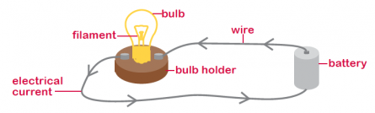

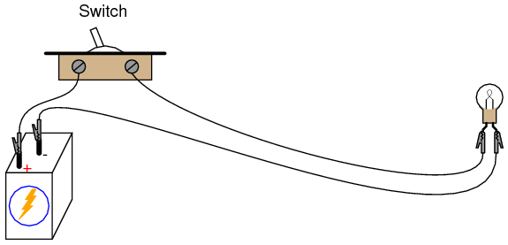

Conductors
SCIENCE
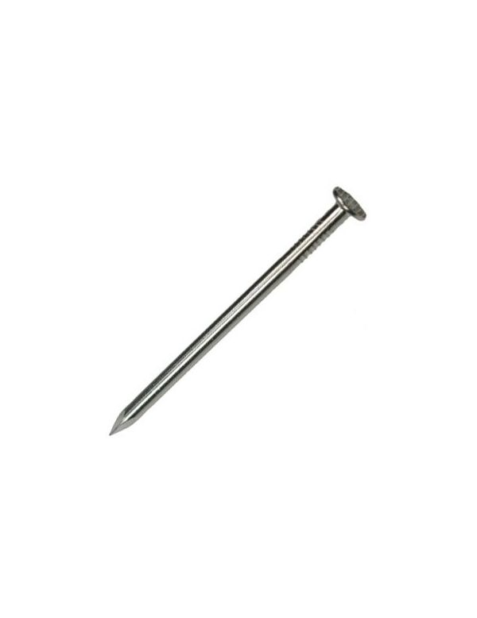
Some materials let electricity pass through them easily. These materials are known as electrical conductors.
Many metals, such as copper, iron and steel, are good electrical conductors.

SCIENCE

Insulators
Some materials do not allow electricity to pass through them. These materials are known as electrical insulators.
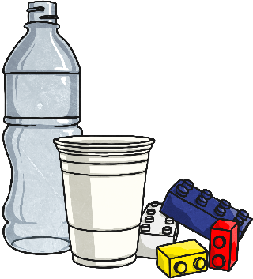
Plastic, wood, glass and rubber are good electrical insulators. That is why they are used to cover materials that carry electricity.

